- Abstract
- Intro- bistability in perception often shows buildup (auditory specific or general – list examples?) This extra time it takes to get from perceiving one object to two objects is often understood as evidence accumulation, eg finding enough evidence to support a complicated scene (with multiple objects) takes longer than creating a percept of a simple scene. Most researchers expect to see a gradual change in neural activity over the course of a trial; however, we show that the apparently gradual increase in probability of a split percept over time could be the averaging over many trials of a process that switches suddenly, but randomly, from a known starting state, and then alternates.
- Methods
  - ARP model- imagine z is a random variable that takes on values {0,1} with random durations at T0 and T1. Z(0) is known to always be 0. The durations are gamma distributed, such that

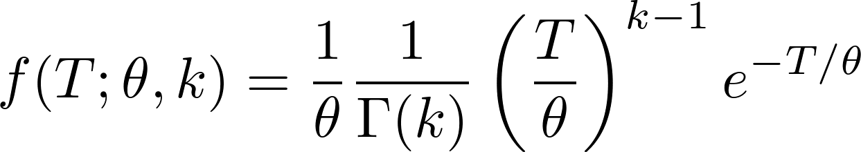

The distribution of durations corresponding to z = 0 has parameters 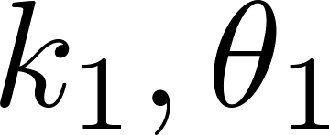 and those for z = 1 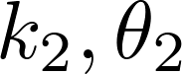. A solution exists for , aka the buildup function. We can write this solution analytically in the Fourier domain as
- competition model
- Results
- Discussion
- Conclusions

